Pokhara University

Level: Bachelor | Semester – Fall | Year : 2010
Programme: BE |  | Full Marks : 100
 |  | Pass Marks: 45
Course: Engineering Mathematics I |  | Time : 3hrs.

Candidates are required to give their answers in their own words as far as practicable.
The figures in the margin indicate full marks.

Attempt all the questions.

1. | a) Examine the continuity and differentiability of the function f(x) defined as follows:  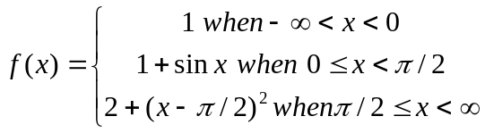  OR  a) If 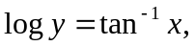show that  i) 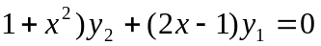  ii)  b) State and prove Cauchy Mean value theorem. If f(x)=sin x in 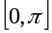, find the value of c prescribed by Rolle's theorem. | 8  7
2. | - A cylindrical tin can closed at both ends with given capacity has to be constructed. Show that the amount of tin required will be minimum when the height is equal to the diameter.  - Define asymptotes. Find the asymptote of the curve: 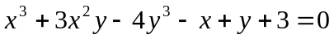  OR  State and prove L-hospital's rule. Also evaluate: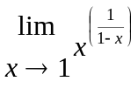 | 8  7
3. | Evaluate any three:  a)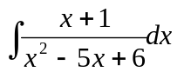 b)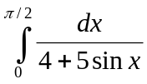  c) 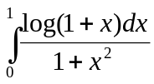 d) 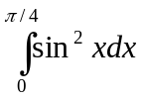 | 3x5
4 | - Find the area between the curves 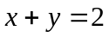 and   OR  Find the volume of solid generated by revolving the region enclosed by the triangle with vertices (1, 0), (2, 1) and (1,1) about the y-axis.  - Find the approximate area using Simpson's and trapezoidal rule for the region bounded by curve 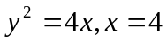 and x =9 with x-axis. Compare with exact value. | 7  8
5 | - Define vector product of four vectors. Show that the vectors  is parallel to the vector .  b) Find the equation of the plane through (3,2,1), (-1,1,-2) and (3,-4,1) | 7  8
6 | - Find the condition that the line y = mx + c will be tangent to the ellipse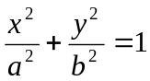  - Obtain the vertices, coordinates of foci, directrix, and eccentricity of the following hyperbola 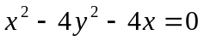. | 7  8
7. | Attempt all the questions  - Find the domain and range of the function y= 2 cos x  - Evaluate 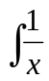 log x dx  - Find the radius of curvature at (1, 1) of y = 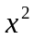  - Find vertex,, line of symmetry and focus of 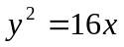  - If 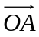=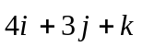, 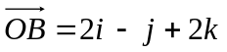, find projection of 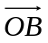 | 5x2

